**Great Bentley ‘Green Gym’**

*Answering your Questions!*

**Question:** *How have we paid for this outdoor fitness area?*

**Answer:** *As part of the planning for housing developments, Section 106 money was allocated for the development of play areas. GBPC were granted an ‘amendment’ to the conditions and have received full funding for the area.*

*None of the ‘precept’ has been used.*

**Question:** *How do I use the equipment?*

**Answer:** *GBPC have been fortunate in obtaining the free services of Gary De La Nougerede from COMIIT fitness who will be providing a free weekly, introductory session to anyone wishing to learn more about how to use the equipment. You can still use the equipment without attending the session.*

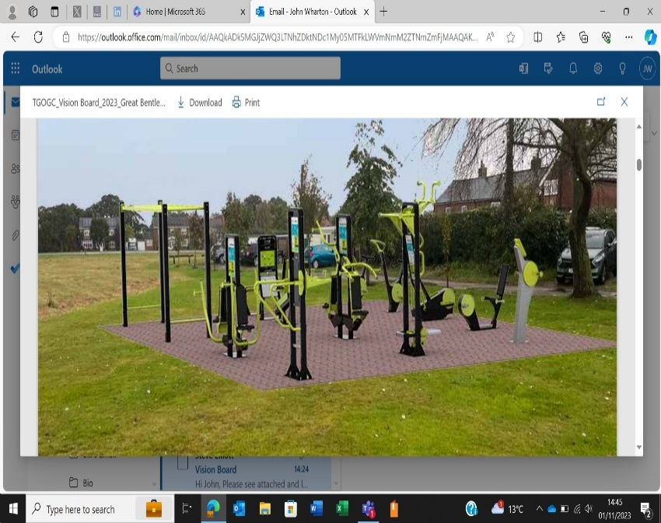

**Question:** *Why has the fitness area been located near the play area?*

**Answer:** *The location was chosen to encourage usage of the area and promoting the opportunity for adults to train whilst their children use the play area. It is also more accessible from Forge Lane with those with mobility issues.*

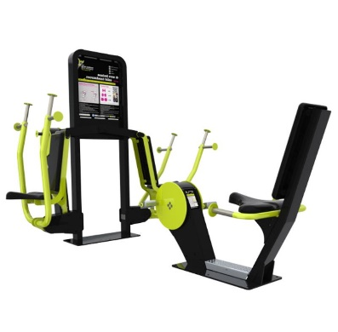

**Question:** *Why do we need a fitness area / gym in Great Bentley?*

**Answer:** *GBPC have a commitment to improve the physical and mental wellbeing of all residents. The building of the fitness area is a result of a 14-month project to provide a state-of-the-art fitness experience accessible to all. The launch of the fitness area will be the spear head event for the council’s ‘Fitness 43 Initiative’ encouraging ‘Active Living – Better Wellbeing’.*

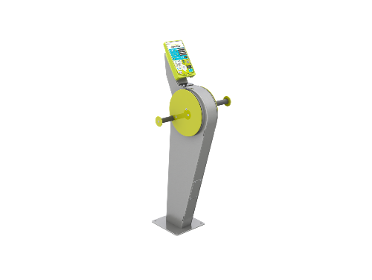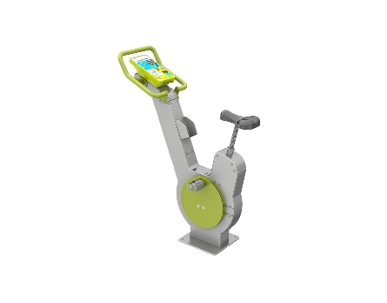

**Question:** *What is the ‘Fitness 43’ Initiative?*

**Answer:** Fitness 43 is a council initiative to increase awareness of the numerous and diverse sport and physical activities available in Great Bentley. If football, cricket or running isn’t your ‘thing’, why not try some yoga or table tennis or badminton. We will also be looking to set up a ‘walkie talkie’ group in the village for those who would like to take part in a weekly walking group.

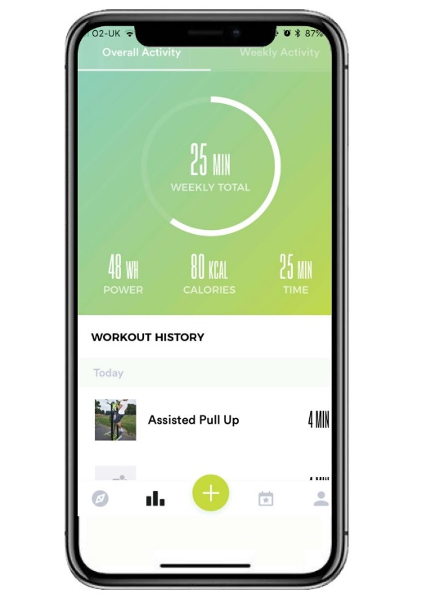

**Question:** *Why should I use the TGO Activate App?*

**Answer:** The application includes a dedicated page for the Great Bentley fitness area and it is free! Other benefits include learning about the equipment, logging and tracking your activity, connecting with other users in the village and staying informed of any ‘Green Gym’ events.

No problems if you do not want to use the app, you can still use the fitness area. The choice is yours! Guidance on how to set up the app will be provided at the launch event and the weekly introduction sessions.

**Question:** *What makes the equipment different from other villages where equipment isn’t used?*

**Answer:** Each piece of equipment has comprehensive instructions and a QR code for your mobile phone to show you a video of how to use the equipment. All the CV equipment (bikes, cross trainers and hand bikes) have Bluetooth to allow you to track and record your progress and also generates electricity to enable you to charge your mobile whilst training. You do have to remember to bring your own phone power cable!