Parish Council Emissions Audit 2022-23
Contents
Background 1
Scope 3 categories 3
Further Parish Council Context 4
Method 4
2022-23 4
Results 8
Proposals 9
2023-24 9
Full Council 9
Annex A - Expenses that do not clearly fit into free Normative Business Carbon Calculator’s sub-categories 10

Background
Due to the worldwide climate crisis the UK has set a target to reduce greenhouse gas (GHG) emissions across the country to reach net zero by 2050. Individuals and organisations of all sizes need to play a part in reducing emissions.
Emissions of each greenhouse gas (carbon dioxide, methane, nitrous oxide, fluorinated gases) are expressed in terms of carbon dioxide equivalent (CO₂e), recognising the different global warming potentials of the different gases.
Greenhouse Gas Protocol is an international organisation that provides standards, guidance, tools and training for business and government to measure and manage climate-changing emissions. Two of their standards are:
- Corporate Standard - This standard is written primarily from the perspective of a business developing a GHG inventory. However, it applies equally to other types of organisations with operations that give rise to GHG emissions, e.g., non-governmental organisations, government agencies, and universities.
- GHG Protocol for Cities - The Global Protocol for Community-Scale Greenhouse Gas Inventories 1.1 (GPC 1.1) offers cities and local governments a robust, transparent, and globally accepted framework to consistently identify, calculate, and report on city greenhouse gas emissions.
The Protocol for Cities goes far beyond the emissions a city council would be directly responsible for. Therefore for this Parish Council energy audit the Corporate Standard provides a better starting point. Page 27 in Chapter 4 describes the different scopes of emissions. To summarise:
- Scope 1: Direct GHG emissions
  - This covers emissions due to fuel burnt by people / equipment controlled by the organisation and chemicals used.
- Scope 2: Electricity indirect GHG emissions
  - Organisations report the emissions from the generation of purchased electricity that is consumed in its owned or controlled equipment or operations as scope 2.
- Scope 3: Other indirect GHG emissions
  - This includes emissions generated by the reporting organisation’s suppliers its customers / clients / users. Scope 3 is optional, but it provides an opportunity to be innovative in GHG management. Organisations may want to focus on accounting for and reporting those activities that are relevant to their operations and goals, and for which they have reliable information. Since organisations have discretion over which categories they choose to report, scope 3 may not lend itself well to comparisons across organisations.
For many parish councils only a small portion of the emissions resulting from their activities would be covered by scope 1 and 2. It is therefore important to include scope 3 emissions in any assessment.

Scope 3 categories
- There are fifteen categories of scope 3 emissions. Some examples of parish council activities that fall into each category are provided.
  - 1 - Purchased goods and services
  - 2 - Capital goods
  - 3 - Fuel- and energy-related activities
    - Three activities relevant to the Parish Council:
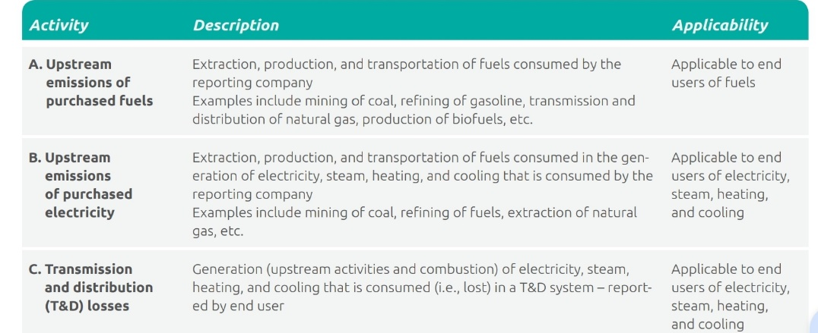
  - 4 - Upstream transportation and distribution
  - 5 - Waste generated in operations
  - 6 - Business travel
  - 7 - Employee commuting
  - 8 - Upstream leased assets
    - Community Resource Centre, space in village hall for meetings
  - 9 - Downstream transportation and distribution
  - 10 - Processing of sold products
  - 11 - Use of sold products
  - 12 - End-of-life treatment of sold products
  - 13 - Downstream leased assets
    - Allotments, use of village green
  - 14 - Franchises
  - 15 - Investments
More details for each of these 15 categories including guidance on selecting the appropriate calculation methods; and examples to demonstrate each calculation method are available at https://ghgprotocol.org/scope-3-technical-calculation-guidance. Many organisations will use integrations with their accounting software to track their environmental impact as well as their financial situation. Stand-alone tools are also available.

Further Parish Council Context
Great Bentley Parish Council uses a Rialtas accounting package. At the time of writing the author could find no reference to carbon footprint specific to Rialtas.

Method

2022-23
- A number of carbon calculators were considered.
- The free https://businesscarboncalculator.normative.io/ is linked from the UN-backed, internationally-recognised SME Climate Hub, and does not require integration with any specific accounting package.
- Since this is a “Business Carbon Calculator”, not a “Parish Council Carbon Calculator” The author contacted Normative, explaining the parish council’s activities, stating that it is not a business but is like a business in many respects and asking if they were happy for the PC to use.
  - Reply: “Be aware that the carbon footprint you get from the BCC is an estimate which is not validated by our sustainability experts. It also can only accept spend data for scope 3 inputs so it might not give you the complete picture you might need. Just some caveats to keep in mind.”
    - Examples of things that are not accounted for:
      - Investments
      - Downstream Scope 3
      - No separate category for leased assets
- Despite the limitations this calculator was selected as the most suitable free tool and is widely recommended
- Initial inputs provided
  - Number of people working for organisation
  - Income
  - Litres of fuel used in organisation’s owned or long-term leased vehicles / machinery
  - Floor space of organisation’s facilities (including warehouses and garages but not including outdoor space) - For Great Bentley this is the Community Resource Centre, estimated at 12m²
  - Electricity consumed - Since the parish council is not billed separately for electricity used at village hall / Community Resource Centre this only accounted for street lighting
  - The tool asks whether 100% renewable energy is used.
    - The supplier for electricity for street lighting for 2022-23 was Drax. Drax are the subject of a complaint to the UK Government’s Department for International Trade from a group of NGOs (The Lifescape Project, The Partnership for Policy Integrity, RSPB, Biofuelwatch, Save Estonia’s Forests, and Conservation North). The complaint alleges Drax made misleading or inaccurate statements about their business’ carbon emissions, and the environmental impact of their business activities. The assessment panel has found parts of the complaint merit further consideration.
    - The author therefore responded “No” to the question regarding whether 100% renewable energy is used.
  - Heating method and consumption details
    - For Great Bentley PC this is included in rent
The tool then asks for the total expenses excluding salary, taxes, and any costs pertaining to fuel usage, heating, or electricity covered in previous questions. It encourages uses to assign at least 85% of expenses to the following categories and sub-categories.
Business travel  Train tickets  Flight tickets  Bus tickets  Car rental  Hotels & Restaurants | Transport / Freight  Road Freight  Air Freight  Sea Freight  Rail Freight  Other transport services (Warehousing etc)

Materials / Inventory  Furniture  Paper and packaging  Textiles  Plastic products  Metal products  Wood products  Chemicals and pharmaceuticals  Other general products  Books, movies and related services | Capital goods  Phones, television and communication equipment  Computers and office machinery  Purchased vehicles (Motor Vehicles, Trailers, Boats etc)  Other machinery, tools and equipment

Services
Legal, Accounting and Management Consultancy
Software, Hosting, Computer Programming & Related Activites
Insurance and pension funding
Financial intermediation (i.e. banking charges)
Construction and maintenance
Prior to agreeing to complete an emissions audit the Parish Council had already set budgets against cost codes for 2022-23.
The most detailed breakdown available is the PC Detailed Receipts & Payments by Budget Heading Cost Centre Report (Full PC Agenda Item 04.06.23).
Some of the items of expenditure span multiple categories / sub-categories and even scopes. Significant examples of this include:
- Grass Cutting/Strimming Contract - The value for this includes the cost of the diesel which can be accounted for in the parish council’s Scope 1 emissions. The diesel cost was therefore subtracted from the value for this item from the PC’s Cost Centre Report.
- Training, Travel and Subsistence - It was assumed course fees are far more significant than travel / subsistence so the full cost was assigned to Legal, Accounting and Management Consultancy.
Additional details regarding items which did not clearly fit into one of the categories are highlighted at the end of this document.
The total expenses excluding salary, taxes, and any costs pertaining to fuel usage, heating, or electricity covered in previous questions for 2022-23 were £50,282. The breakdown shown below shows £45,169 classified, 89.8% of the £50,282.
Category | Sub-Category | Value
Services | Construction and maintenance | £20,982
Capital goods | Other machinery, tools and equipment | £8,045
Services | Legal, Accounting and Management Consultancy | £7,497
Services | Software, Hosting, Computer Programming & Related Activites | £2,981
Services | Insurance and pension funding | £2,411
Capital goods | Computers and office machinery | £2,163
Materials / Inventory | Wood products | £450
Materials / Inventory | Other general products | £385
Services | Financial intermediation (i.e. banking charges) | £255

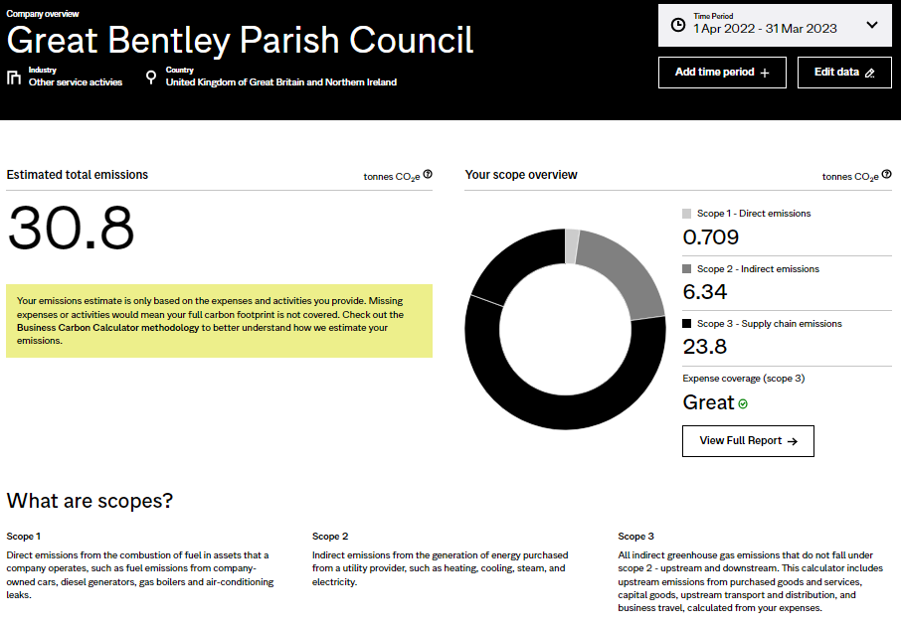
Results

The estimated total emissions of 30.8 tonnes of CO₂e is roughly equivalent to an average passenger taking a return flight to New York fourteen times.

The breakdown of the Scope 3 emissions included in the “Full Report” is: | Scope 3 % of Scope 3 emissions tonnes CO₂e  Purchased goods and services 87.5 % 20.6  Capital goods 12.5 % 2.95

Proposals

2023-24

Full Council
- The parish council authorise the publication of this emisssions audit
- Conduct an emissions audit annually
- Split budget for Grass Cutting/Strimming Contract into two separate cost codes so the Scope 1 emissions due to the parish council tractor burning diesel are accounted for separately.
  - The amount spent on diesel for the tractor in 2022-23 was £474.93 excluding VAT or £569.92 including VAT. Note this may have been a particularly dry year during which grass grew less quickly than normal.
- Split budget for training, travel and sustinance into three separate cost codes.

Annex A - Expenses that do not clearly fit into free Normative Business Carbon Calculator’s sub-categories
Item | Value | Classification used 2022-23 |  | Rationale
Clock/Not'boards/Benches/Bins | £2,106 | Capital goods | Other machinery, tools and equipment | Assumed this was mainly replacement or additional provision, not servicing of existing
Training, Travel and Subsist. | £1,785 | Services | Legal, Accounting and Management Consultancy | Assumed course fees significantly larger component than travel and subsistence
Benches (funds donated) | £1,488 | Capital goods | Other machinery, tools and equipment | Assumed the "Materials / Inventory" section should primarily be used for items that companies would use in products or operations in a far shorter time than the expected life of a bench
Discretionary Grants | £1,175 | Unclassified |  | The free Normative Business Carbon Calculator does not account for downstream Scope 3 emissions
Allotment Water | £1,171 | Unclassified |  | No appropriate category available in free Normative Business Carbon Calculator
Village Hall Hire (Meetings) | £928 | Unclassified
Advertising | £832 | Unclassified |  | Author didn't know what type of advertising, so couldn't classify
Mobile Toilets | £745 | Services | Construction and maintenance | The task of delivering, collecting and servicing these would be similar to maintenance
Working from Home Allowance | £442 | Unclassified |  | Relatively small expenses - accounted for as part of the 9.8% of expenses that were not classified
Section 137 | £375 | Unclassified
Christmas Lighting | £122 | Unclassified
Queen's Jubilee | £41 | Unclassified
Operation London Bridge | £27 | Unclassified

Source: https://www.worldlandtrust.org/carbon-calculator/individual/flights/flights-calculator/)

