Guide to Making a Comment

https://www.essex.gov.uk/replacement-essex-minerals-local-plan-review-2025-2040/tell-us-your-views

Please remember that the consultation closes at 17:00 on Tuesday 19th March.

1. To comment on the application – click on the above link or type it into your search bar.

2. Click on this box:

3. Scroll down the page and click on:

4. This will take you to the page for comments on individual sites, and looks like this:

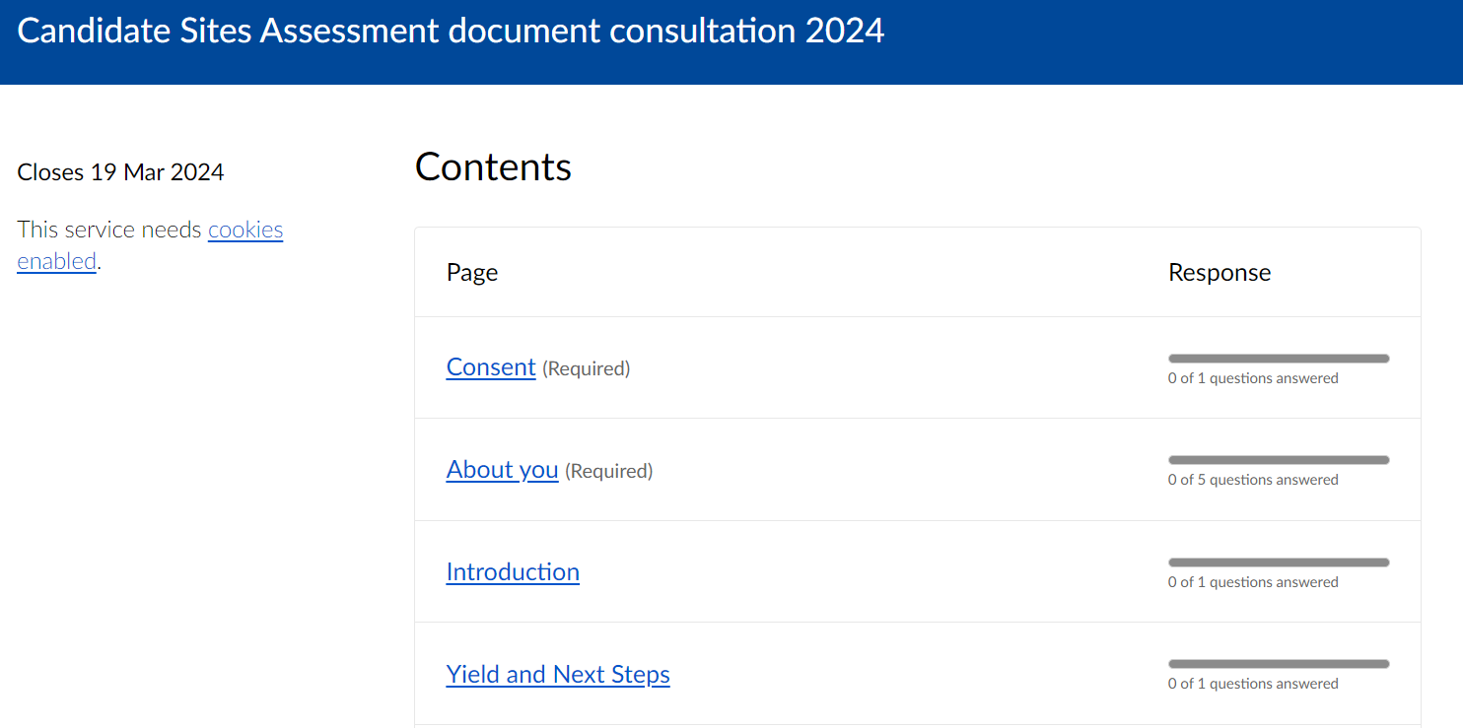

You need to fill out all these boxes before you can make a comment on the relevant site.

5. Scroll down to the most relevant site within Great Bentley:

A68 – Crabtree Farm (Great Bentley) Tendring

Click on this and it will now take you to the section to make your comment.

It is important to note here that there are a further 2 proposed sites on the borders of Great Bentley, Sites A88 (Gurnhams Farm) and A69 Frating Hall, which although not in the parish boundaries will have a negative effect on Great Bentley.

If you are unable to make a comment online, you can also email your comment to:
mandwpolicy@essex.gov.uk

Alternatively, you can download the postal response form off the site, (we have put a copy on our website for ease of use) but we are also happy to print any that are needed, please just contact clerk@greatbentleyparishcouncil.co.uk

The Freepost address for them to be sent back to is:

Freepost RTKH-XUBZ-CJZS
Essex County Council
Minerals Planning Consultation
County Hall
Chelmsford
Essex
CM1 1QH

