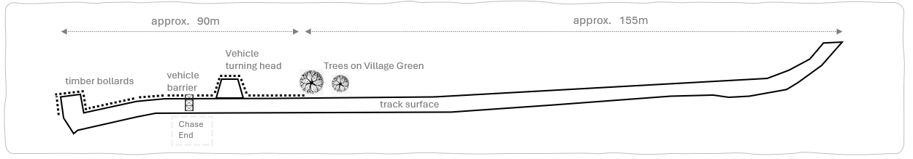

Wednesday 21st February 2024
07:00 pm
Great Bentley Village Hall

