IMPROVED FINANCIAL FORECAST REPORTED BY COUNCIL
Updated figures for the next financial year show an improved budget position for Tendring District Council (TDC) in 2024/25.
The authority’s forecast deficit for 2024/25 has fallen by £960,000 to £1.7 million, a Cabinet meeting heard on Friday, 26 January.
A report setting out the updated position included details of the provisional grant settlement from government to local authorities, and some changes to cost pressures and savings within the council.
It also includes a marginal reduction in the proposed council tax charge for next year.
Cost pressures faced by the authority are largely outside of the council’s control, including inflation, increased staff costs and reduced government funding – all of which are baked into future budgets.
The proposed TDC council tax charge on an average (Band D) home is £193.73 - £3.72 per week – an increase of £5.62 on this year.
SUNSPOT SHORTLISTED IN ARCHITECTURE AWARDS
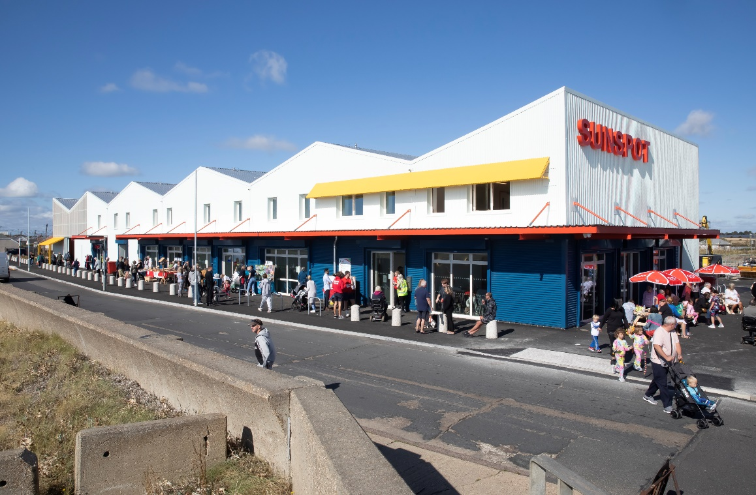
The Sunspot development in Jaywick Sands has been recognised for its architecture.

The commercial workspace and retail development, run by Tendring District Council (TDC), has been shortlisted for a 2024 MacEwen Award – a scheme run by the RIBA (Royal Institute of British Architects) Journal.
Designed by Colchester-based HAT Projects and built by Essex firm TJ Evers, the Sunspot is a £5.3 million project made up of 24 commercial units – a mixture of retail and office space – along with a covered market, event space, café and other amenities.
It received £2.39 million from the Government’s Getting Building Fund administered by the South East Local Enterprise Partnership (SELEP), with an additional £2.04 million funding coming from Essex County Council (ECC), and £816,000 from TDC; which is also using part of its UK Shared Prosperity Fund allocation for operating costs.
Sunspot is one of 13 projects to be shortlisted in the award, and is in the final two in the Workplace and social enterprise category – and the winners are due to be announced at the end of this month (January 2024). This follows other recognition in the architecture sector, with Observer critic Rowan Moore listing Sunspot as one of the five best architecture projects of 2023 – describing it as “a new landmark” for Jaywick Sands.

CLACTON AIRSHOW TO CONTINUE FOR ANOTHER FOUR YEARS
Clacton Airshow – which is staging its 31st event this year on 22-23 August – regularly attracts 250,000 visitors over the two days, and is worth an estimated £12.2 million to the local economy.
“It also involves a serious commitment of money, time and resources from this council; all things we – like local authorities up and down the country – do not have endless supplies of and need to carefully consider where we use them.
The decision does not mean that the Airshow will end in 2027, but will naturally be subject to a further review and commitment.

TENDRING DISTRICT COUNCIL’S CAREER TRACK RATED ‘GOOD’ BY OFSTED
Career Track has been rated as Good by Ofsted following its latest inspection.
The apprenticeship provider run by Tendring District Council (TDC), which turned 40 last year, was visited in November 2023 by inspectors who found Career Track was Good across all areas.
The service runs a number of apprenticeships at both level two and three, with a number of apprentices at TDC but also at other local authorities across Essex, Suffolk and Kent and some local businesses too.
During the three-day visit inspectors found that apprentices enjoy their learning, feel valued, safe, and are highly motivated to successfully complete their training – with most securing employment at the end of their apprenticeship.
In its report Ofsted noted that Career Track has developed “ambitious programmes… which provide a good route to employment and further training for local residents who have low prior-educational achievement and/or low ambition”.
It praised the support given to apprentices by both Career Track assessors and the employing managers, and also the expertise and experience of the governors.

PRINCES THEATRE UNEARTHS HIDDEN HISTORY DURING REFURBISHMENT

Hidden history has been unearthed at the Princes Theatre by staff carrying out refurbishment work.
Whilst removing the stage surface to assess the original structure, which was built between 1928 to 1931, staff substantiated rumours that this contained a large trapdoor leading down to the cast’s dressing rooms, and also found old cigarette packets that appear to have been left by the original builders.

Excitement peaked when staff discovered old electrical outlets that would have been used to control stage lighting and hidden within, a handwritten note from the past with the name Ron Jessop, dated 03/02/1993 and the words ‘Prince Theatre’.
The theatre management believe this person was an outside contractor as the 's' is missing from Princes, an unlikely mistake to have been made by a member of staff, and would like to track down Mr Jessop to say his message was found.
In response, a time capsule was planted for future generations of theatre staff to find before resealing the stage. This contained the original note and one of their own containing a list of names of the staff working at the theatre and the message ‘hello from the past to the future’.
Opened in 1931 by H.R.H Prince Arthur of Connaught, the main auditorium of the Princes Theatre has fittingly been redecorated in a regal red, white and gold colour scheme, as part of an ongoing maintenance programme funded by the Princes Theatre restoration fund.

Lynda

Cllr Lynda McWilliams
Tendring District Councillor for The Bentleys and Frating Ward

Mobile Phone number 07564 613603

