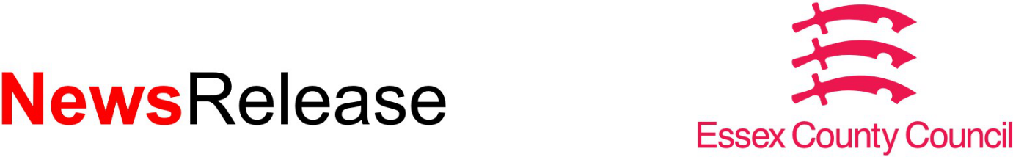

05 January 2024
Ongoing investment in Essex bus provision confirmed

Decision follows consultation seeking feedback from residents on the services that taxpayers support across the county.
Ongoing investment will be made in a large network of local bus services across the county, Essex County Council has confirmed.
A consultation with residents showed it was clear there was strong support for local services and highlighted the essential role they play in people’s lives.
As a result, the council has decided to continue supporting over 150 routes that take people to work, school, shopping and healthcare, with on-demand bus service DigiGo also playing a bigger role in providing its service to more Essex communities.
Essex County Council subsidises around 15% of bus services in the county because they are not commercially viable. These non-commercial services mainly operate in rural areas, at less popular times for travel and provide vital journeys for residents.
Bus use has been on the increase since the Covid-19 pandemic, with residents returning to buses as an effective means of travel and new ways of working have bedded in.
As a result of the consultation, over 150 routes will continue, with new contracts to be procured. Some will be replaced with the DigiGo service, and a very small number (seven) will cease because they are low use. Most of the changes will happen in July 2024 when contracts expire.
Councillor Tom Cunningham, Cabinet Member for Highways, Infrastructure and Sustainable Transport, said: "Bus services across Essex provide a vital transport link for many people. From those who rely on buses to help them access vital services, to those choosing to take the bus instead of car, it's vital Essex County Council continues to invest and support the network alongside bus operators so it can continue to grow.
"What this decision means is that Essex will continue to have a well-supported local bus network, and I'm particularly delighted that we've been able to seize the opportunity to expand the service that DigiGo will provide. This will mean even more communities can benefit from this fantastic on-demand service."
For more information on the outcome for each of the services consulted on, please visit: https://cmis.essex.gov.uk/essexcmis5/Decisions/tabid/78/ctl/ViewCMIS_DecisionDetails/mid/422/Id/9815/Default.aspx.
ENDS
Notes to editors:
The information about the outcome of each service consulted on is set out in a series appendices on the website.
- for all services the consultation response and outcome is summarised in appendix A.
- all routes listed in appendices B and C will continue and the contracts to deliver the services will be procured until at least 2028
- all routes listed in appendices D and E will continue and be procured until at least 2026
- everything in appendix F will be covered by an extended DigiGo service
The following will be redesigned or combined with other services and procured until at least 2026:
- 50B Colchester to Tollesbury/East Mersea/Layer Breton/Tiptree/Gt Wigborough, Monday
- 69/69A Colchester to Tollesbury/East Mersea/Layer Breton/Tiptree/Little Horkesley, Tuesdays
The following services will be procured until at least 2026 but only if the cost for each passenger journey at the time of tender is £10 or below. If the cost is higher than £10 the services will be withdrawn:
- Service 7 Southend to Rayleigh Monday to Saturday Evenings, will therefore be re-designed to withdraw the later journeys
- Service 15 Colchester/Lexden to Marks Tey/Colne Engaine/Bures
Monday to Friday will be highlighted as appropriate for interworking with other services
Service DaRT7 will be included in a devolution pilot along with services SB12 and 211/212.
The following services will be withdrawn because there are alternative services available:
- Harlow service 6 be withdrawn as it is due to be replaced with another s106 funded service in spring 2024 which will be procured in the new year
- F315 service to be withdrawn because passengers are able to use the DaRT3 service and therefore DaRT3 is retained until 2026 as the additional patronage will support its sustainability
- DaRT5 and DaRT4 are withdrawn and replaced with a new timetabled service (service 45). This will leave the following community without a service: Latchingdon, which will still have access to other bus services
The following services will be withdrawn after careful consideration of the consultation responses, current usage and cost to run the services, and assessment of alternative public transport available on the routes, including rail:
- 552 Ramsden Heath to Billericay Station, Monday to Friday
- 256 Basildon/Ramsden Heath to Billericay, Tuesday, Thursday, Saturday
- 84B Colchester to Gt Horkesley/Little Horkesley, Thursday
- 94 South Woodham to South Woodham, Sunday and Public Holidays
- 99 Clacton to Walton, Monday to Saturday Evening
- 804 Debden to Chigwell, Schooldays
- C56 Chelmsford to Galleywood, Sunday and Public Holidays

For Essex County Council media enquiries:
Press Office at press.desk@essex.gov.uk
Out of Hours: 07717 867525
Keep in touch at www.essex.gov.uk, Facebook, Twitter

