Environment 20 Point (E20) Strategy

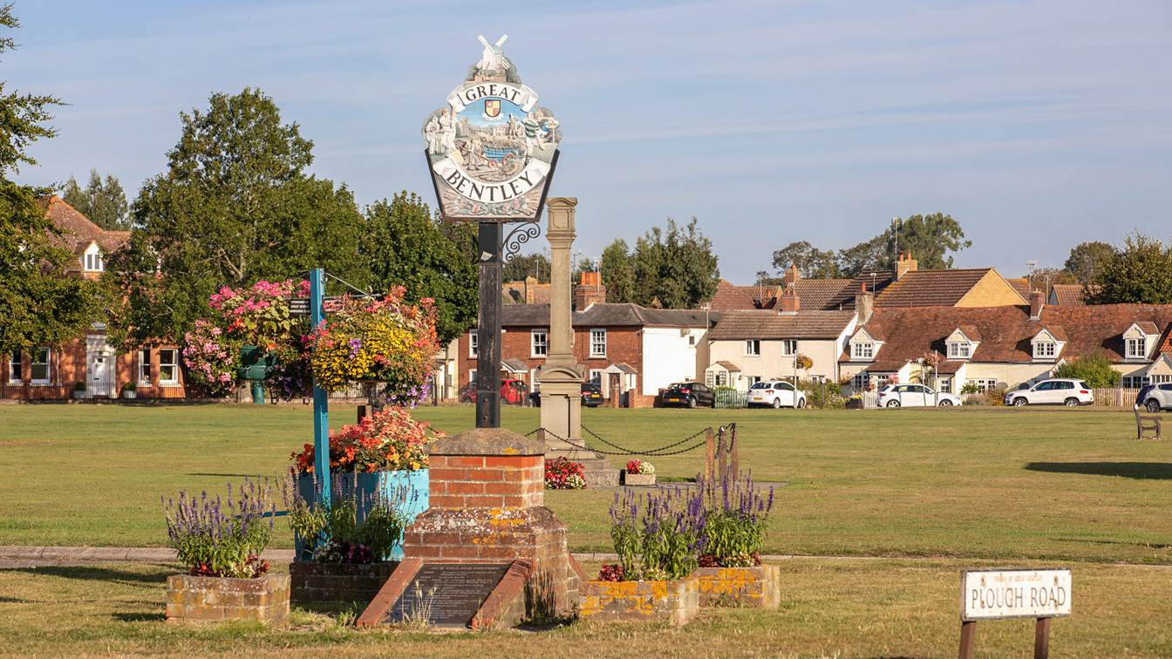

Contributors:
- Councillor Pippa Dennitts
- Jennifer Spear
- Councillor John Wharton MBE
- Andrew Whitefield

Date publishing: 7th September 2023 Date of Review: January 2025

Executive Summary

Great Bentley Parish Council are committed to improving the lived experience of all residents within the parish and recognise the immediacy of a plan of action to address environmental issues.

This Environment 20 Point (E20) Strategy focusses on addressing both climate and ecological concerns and tackling inequalities.

Great Bentley Parish Council will maintain an Environmental Action Plan (EAP) whereby projects are managed and actions recorded to fulfil the obligations stated in the E20 Strategy. An ‘Environmental Working Group’ has been established comprising councillors and volunteers to identify issues and opportunities and work towards achieving the goals listed in the EAP.

Residents will be encouraged to actively support the delivery of the plan and, where possible, suggest new ideas for the benefit of all within the parish. This will be sought during monthly parish council meetings and through active engagement with the community.

Key areas of focus for the E20 Strategy include:

- Enhance the quality of green spaces to promote nature, benefit wellbeing and provide connecting corridors for wildlife;

- Increase climate education through community and school projects and wider engagement across the parish;

- Increase good quality cycling and walking infrastructure to improve health and reduce carbon emissions and air pollution;

- Putting climate and nature at the heart of decision making.

Great Bentley Parish Council cannot achieve these goals without the support and belief from residents and businesses within the parish.

What your council will do:
Putting climate and nature at the heart of decision making
Our goal is to ensure that the climate and nature emergencies are paramount in all our decisions so that we can drastically cut emissions over the next 10 years, and that inclusive engagement with residents ensures that the changes made are sustainable. We will…

1 | Consider the environmental impact of decisions made.
2 | Develop communications with councillors, at both District and County level, to encourage support for Parish Council initiatives and to be kept informed of any other environmental action being undertaken across both District and/or County.
3 | Seek advice from government and industry experts towards achieving the objectives set out in this strategy.

Investing in the future
Our goal is to have sufficient resources to invest in the changes needed to protect nature and meet climate goals, so that our council can reap the dividends and deliver our fair share of reduction in greenhouse gas emissions. We will…

4 | Funding for local environmental projects will be actively sought through annual budgeting, fundraising events and government grants.

Buildings
Our goal is to ensure all homes are energy efficient. We will…

5 | Support owner-occupied homes and tenants be more energy efficient by seeking energy companies to provide fuel-poor or vulnerable households with insulation and other energy efficient services and equipment.

Influencing others
Our goal is to encourage and support other entities with their contribution to addressing the climate and nature emergency. We will…

6 | Use influence with others through information and education including school projects and community engagement.

What your council will do:
Protect the most vulnerable
Our goal is to ensure that people most vulnerable to the effects of climate change are properly supported and protected. We will…

7 | Target climate change, nature and pandemic adaptation policies, actions and spending to vulnerable groups and areas.
8 | Seek the views and opinions of residents, across the parish, when council decision making.
9 | Inform residents of action that could be taken to reduce their carbon footprint and/or support nature.

Waste
Our goal is to be a sustainable consumption and zero-waste area, where all waste is minimised, recycled or reused as part of a circular economy approach. We will…

10 | Promote community sharing and reuse to reduce waste and unnecessary consumption.
11 | Encourage use of recycling services as provided by Tendring Primary recycle scheme.
12 | Minimise Fly Tipping opportunities through restrictions and prosecution.

Transport
Our goal is to significantly and rapidly increase the proportion of people that travel by cycling, e-bikes and walking, as well as public transport when safe to do so. We will…

13 | Work with Tendring District and Essex County Councils to reduce parking congestion across the parish and balance free flow of traffic with maintaining speed limits.
14 | Consider adopting the ‘20’s Plenty’ scheme across selected areas in the parish.
15 | Actively support and encourage the use of accessible public transport including bus and rail.

What your council will do:
Energy
Our goal is to enable and support the growth and use of renewable energy, ensure energy is not wasted, and prevent the development of new fossil fuel extraction. We will…

16 | Switch street lighting to well-designed and well-directed LED lights.
17 | Reduce energy used by the council in our own estate.
18 | Support the development of renewable energy and energy storage.

Land use and nature
Our goal is to ensure everyone has access to nature in nearby green spaces and to restore nature, including to help draw down carbon pollution from the atmosphere. We will…

19 | Protect and enhance existing local green spaces and ensure public access to local authority owned green spaces.
20 | Manage council-owned land and road verges to increase biodiversity and draw down carbon pollution, including through reduced pesticide use and allowing what is already there to flourish.

